**Static Class**

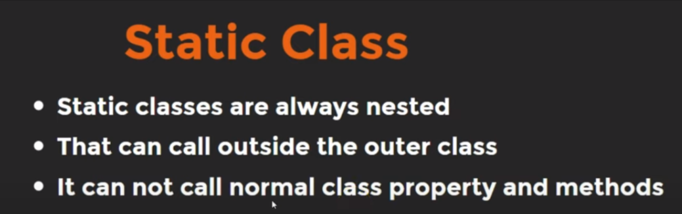

Static class can call outside the outer/parent class.

A static class can only access static variable from outside.

**Example:**

class College {

static String name = "Chandan Kumar";

static class Student {

void getStudentDetails() {

System.out.println(name);

}

}

}

public class Main {

// main Method

public static void main(String[] args) {

College.Student clgStd = new College.Student();

clgStd.getStudentDetails();

}

}

**Output:**

Chandan Kumar